**Spring Core_Maven**

**Exercise 1: Configuring a Basic Spring Application**

* **Scenario -** Our company is developing a web application for managing a library. We need to use the Spring Framework to handle the backend operations.
* **Outline**

* **pom.xml**

* **applicationContext.xml**

* **com.library.service – BookService.java**

* **com.library.repository – BookRepository.java**

* **com.library – MainApp.java**

* **Output – (Right Click MainApp.java -> Run As -> Java Application)**

**Exercise 2: Implementing Dependency Injection**

* **Scenario -** In the library management application, We need to manage the dependencies between the BookService and BookRepository classes using Spring's IoC and DI.
* **pom.xml**

* **applicationContext.xml**

* **com.library.service – BookService.java**

* **com.library.repository – BookRepository.java**

* **com.library – MainApp.java**

* **Output – (Right Click MainApp.java -> Run As -> Java Application)**

**Exercise 4: Creating and Configuring a Maven Project**

* **Scenario -** We need to set up a new Maven project for the library management application and add Spring dependencies.
* **Maven Project – LibraryManagement**

* **pom.xml**

* + Spring Context

* + Spring AOP

* + Spring WebMVC

* **Configuring Maven Plugins**

**Additional Important HandsOn**

**Exercise 5: Configuring the Spring IoC Container**

* **Scenario-** The library management application requires a central configuration for beans and dependencies.
* **pom.xml**

* **applicationContext.xml**

* **com.library.service – BookService.java**

* **com.library.repository – BookRepository.java**

* **com.library – MainApp.java**

* **Output – (Right Click MainApp.java -> Run As -> Java Application)**

**Exercise 7: Implementing Constructor and Setter Injection**

* **Scenario-** The library management application requires both constructor and setter injection for better control over bean initialization.
* **pom.xml**

* **applicationContext.xml**

* **com.library.service – BookService.java**

* **com.library.repository – BookRepository.java**

* **com.library – MainApp.java**

* **Output – (Right Click MainApp.java -> Run As -> Java Application)**

**Exercise 9: Creating a Spring Boot Application**

* **Scenario –** We need to create a Spring Boot application for the library management system to simplify configuration and deployment.
* **Spring Initializr**

* **Outline**

* **com.library – LibraryManagementApplication.java**

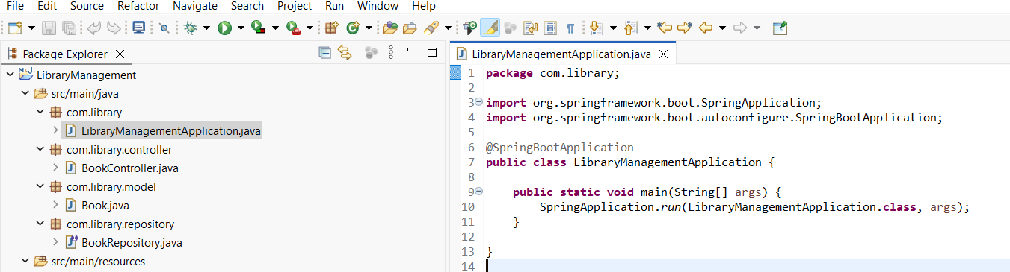

* **com.library.controller – BookController.java**

* **com.library.model – Book.java**

* **com.library.repository – BookRepository.java**

* **application.properties**

* **pom.xml**

* **H2 console -** [**http://localhost:8081/h2-console**](http://localhost:8081/h2-console)

* **After Connecting –**

* **Testing Queries**

* **Output**

